**Ideation Phase**

**Empathize & Discover**

|  |  |
| --- | --- |
| Date | 31 January 2025 |
| Team ID | LTVIP2025TMID59486 |
| Project Name | ShopEZ: One-Stop Shop for Online Purchases |
| Maximum Marks | 4 Marks |

**Empathy Map Canvas:**

An empathy map is a simple yet powerful visual tool that captures insights into a ShopEZ user's thoughts, feelings, and behaviours. It helps the team build a shared understanding of customer needs, motivations, and pain points throughout their shopping journey.

By mapping out what users see, say, do, think, feel, and hear, the team can better empathize with them and design meaningful, user-centred solutions. This process ensures that every feature developed in ShopEZ—whether a product filter, checkout process, or seller dashboard—is tailored to solve real problems and support the goals of the people using it.

**Example:**

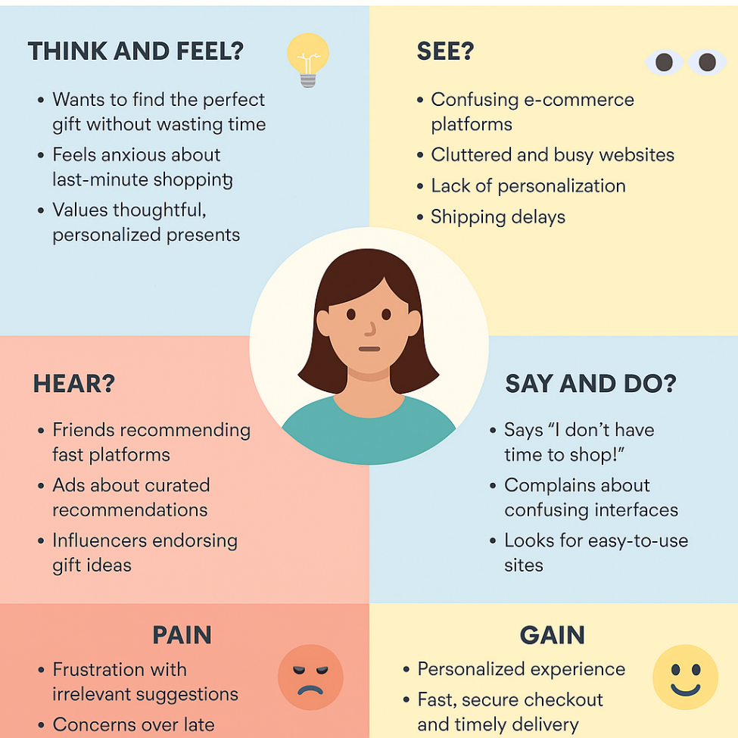

Reference: <https://www.mural.co/templates/empathy-map-canvas>

**Example: shopEz**

